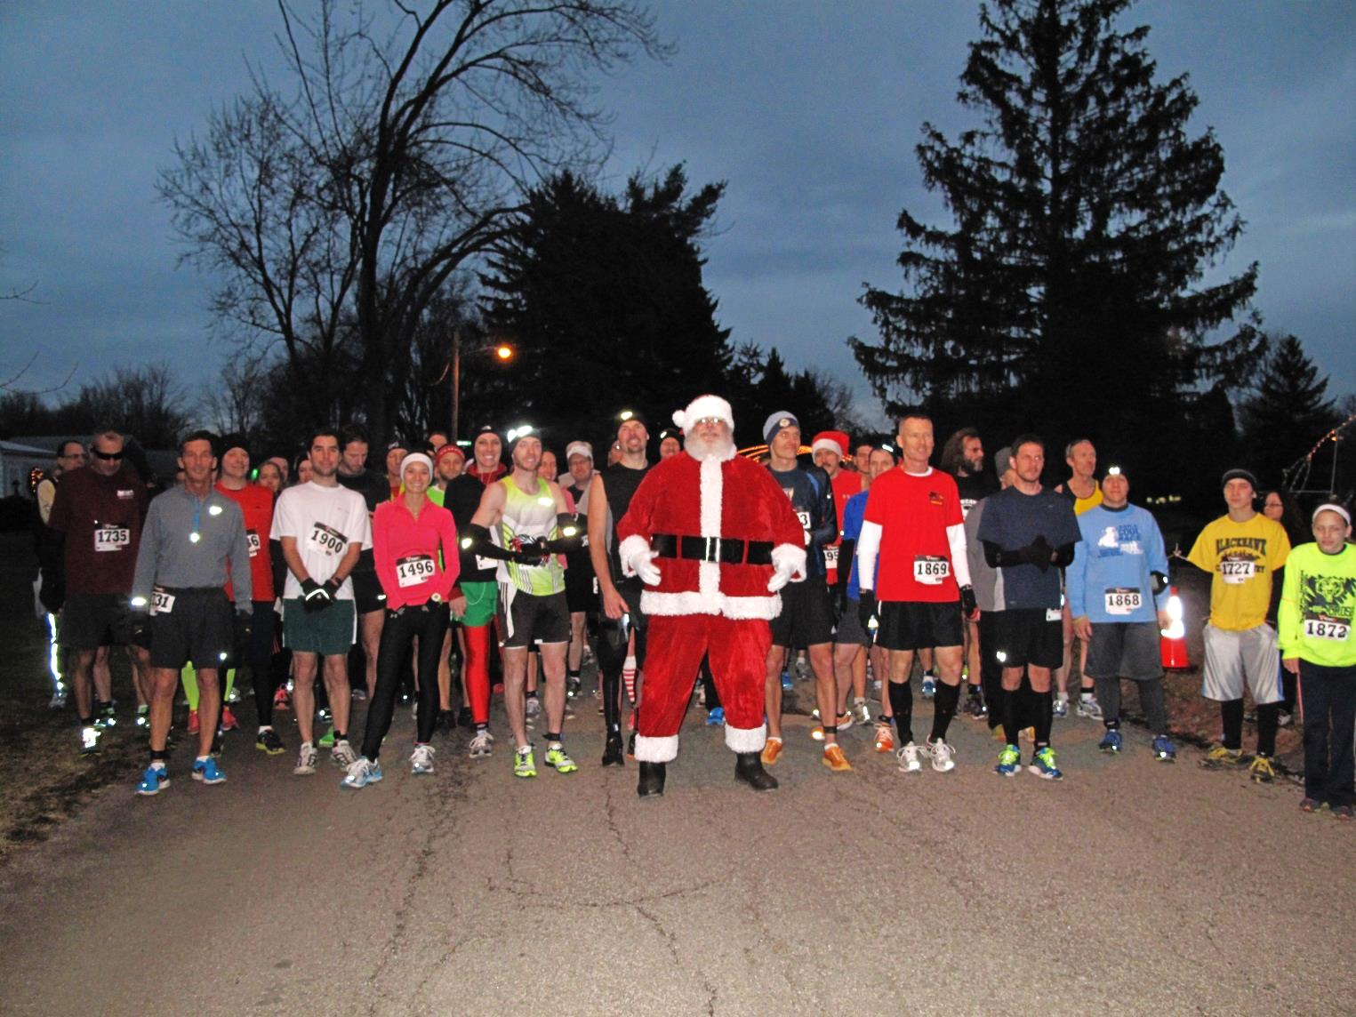

***For questions contact race directors***

***Josh & Crystal Boggs at fhvision@mail.com or 330-482-9105***

***Race Website: www.SandBFoundation.org***

4:00pm- Registration Begins (Pavilion #1)

6:00pm- Start 5K Run

Address: 347 East Park Ave. Columbiana, Ohio 44408

**Early packet pick up available at Second Sole Boardman on Sunday, Dec.10th from 12-4pm**

***Online registration available at www.secondsoleohio.com***

**Name ________________________________________________**

**Address _______________________________________________**

**Age on Race Day ____ Sex____ Shirt Size: YL S M L XL**

**Email _____________________________ Phone _______________**

**Additional Donation (Optional) __________________________________**

**Signature (parent if under 18) __________________________________**

RELEASE: I, the undersigned, realize that running/walking a road race is a potentially hazardous activity. I should not enter and run/walk unless I am medically able and properly trained. I agree to abide by any decision of a race official relative to safely completing the run/walk. I assume all risks associated in participating in this event include, but are not limited to, falls, contact with other participants, the effects of the weather, road conditions, and lighting of the race course and surrounding areas; all such risks being known and approved by me. I agree to have images of me released to the media without compensation. Having read this waiver and knowing these facts and in consideration of you

accepting my entry, I, by myself, and anyone entitled to act upon my behalf, waive and release Firestone Park, the City of Columbiana, Siembida & Boggs Philanthropic Foundation, race directors, volunteers, all sponsors, and their representatives and successors, from all claims of liability of any kind rising out of my participation in this event.

**Twas the Night Before 5K**

***A festive 5K through the Joy of Christmas light show in Firestone Park***

**Early registration forms can be sent to:**

**759 Fairfield Ave, Columbiana, OH 44408**

**Please make checks payable to: S & B Foundation**

**$20 if received by Nov. 30th**

**$25 after Nov. 30th and on race day.**

***\*\* Please wear reflective gear and lighting as course is dark in areas \*\****

Wednesday, December 13th, 2017

Fifth Annual